Project Design Phase
Solution Architecture
Date | 24 September 2026
Team ID | SWTID-2026-7288
Project Name | AI BlogNest API
Maximum Marks | 4 Marks

Solution Architecture:
The solution architecture for AI BlogNest API connects the user-facing blogging requirements with a secure Express REST backend, AI-assisted content services, structured MongoDB storage, and supporting configuration and logging components. The architecture is based on the supplied project technology stack and represents the flow of requests, processing, storage, and responses.
- Provide a REST API layer for blog creation, management, and content access.
- Connect AI-assisted operations to the Google GenAI service through the backend.
- Use MongoDB with Mongoose for persistent application and blog-content data.
- Apply JWT authentication, password hashing, request validation, rate limiting, Helmet, and CORS controls.
- Keep configuration outside source code through environment-based settings and support operational request logging.
AI BlogNest API – Solution Architecture Diagram:
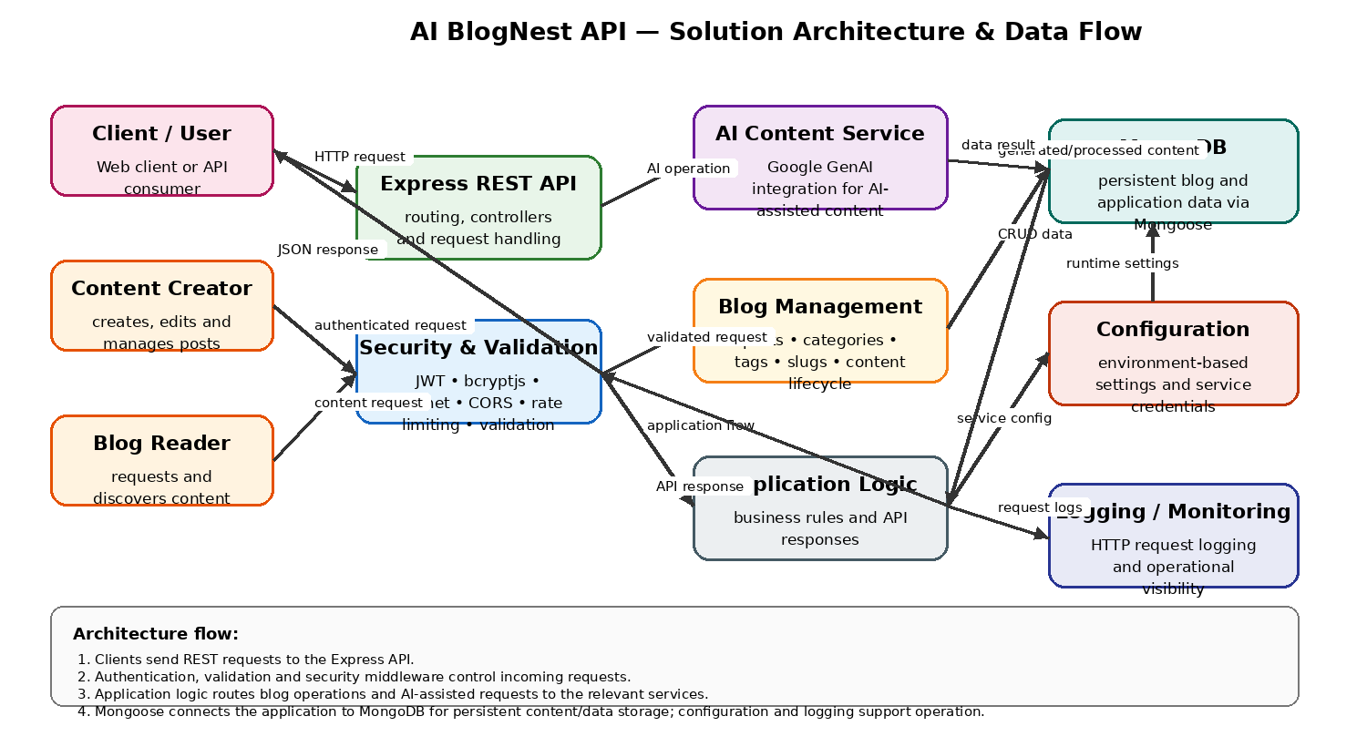
Figure 1: Architecture and data flow of the AI BlogNest API
Reference: https://learn.microsoft.com/en-us/azure/architecture/guide/architecture-styles/

